WEB COMPUTING
4. Node.js
4.1 Environment setup, First app, Asynchronous programming, Callback concept, Event loops, REPL, Event emitter, Networking module, Buffers, Streams, File system, Web module
PAST QUESTIONS:
- What is Node.js? What are the advantages of using it? Demonstrate the working of Node.js by creating a simple server to display a “Welcome” message. (D22)
- Explain the architecture of Node.js with a neat diagram. Demonstrate its use by writing the code which creates a simple text file with the data provided by the user. (D22)
- Write the program to create a simple HTTP server to display a welcome message with node.js. (M23)
- Explain different types of node.js modules? What are different modules that provide core functionality? (M23, D23)
- Explain the working of the event loop along with different phases of node.js with a neat diagram. Write an asynchronous file reading node.js program and explain how it is executed. (M23)
- What is callback in node.js? Give an example. (D23)
- Explain the architecture of node.js with a neat diagram. Write an asynchronous file reading node.js program and explain how it is executed. (D23)
- Event loop in node.js. How does it handle asynchronous operations? Provide examples.
- Explain how Node.js handles asynchronous operations using callbacks, Promises and async/await. Provide examples.
- Streams to read and write data efficiently.
NOTES:

*Node.js :-
Node.js is an open-source, cross-platform JavaScript runtime environment built on the V8 JavaScript engine from Chrome. It allows developers to execute server-side JavaScript, enabling them to build scalable and high-performance network applications. Node.js is event driven and non-blocking, making it well-suited for handling concurrent connections and building real-time applications.
Features of Node.js:
1.Non-blocking I/O: Node.js is designed to be non-blocking, which means it can handle many concurrent connections simultaneously without waiting for one operation to complete before moving on to the next.
3.NPM (Node Package Manager): Node.js comes with npm, a powerful package manager that facilitates the installation and management of third-party libraries or modules. The npm ecosystem is extensive, providing a wealth of reusable modules that developers can easily integrate into their projects.
4.Cross-platform: Node.js is designed to be cross-platform, allowing developers to write server-side applications using JavaScript that can run on various operating systems, including Windows, macOS, and Linux.
5.Fast Execution: Node.js is built on the V8 JavaScript engine, which compiles JavaScript code into native machine code for faster execution. This contributes to its overall performance and efficiency.
6.Scalability: Due to its non-blocking, event-driven nature, Node.js is well-suited for building scalable applications.
Advantages of Node.js:
1.High Performance: Node.js is known for its high performance, thanks to the V8 engine and its non-blocking I/O model. This makes it well-suited for building applications that require speed and efficiency.
2.Scalability: Node.js's ability to handle a large number of concurrent connections makes it a great choice for scalable applications.
3.Large Ecosystem: The npm ecosystem is vast, providing a wealth of open-source modules and packages that can be easily integrated into Node.js projects. This reduces development time and effort.
4.Unified Language: The use of JavaScript on both the client and server sides allows developers to use a unified language throughout the entire application stack. This simplifies development and promotes code reuse.
5.Community Support: Node.js has a large and active community of developers, contributing to its growth and continuous improvement. The community provides support, shares knowledge, and creates a wide range of tools and libraries.
6.Ease of Learning: For developers familiar with JavaScript, the learning curve for Node.js is relatively low. The ability to use JavaScript for both front-end and back-end development streamlines the development process for those already proficient in the language.
7.Flexibility: Node.js is suitable for a variety of applications, ranging from small, lightweight projects to large-scale, enterprise-level applications. Its versatility makes it a popular choice for different types of development projects.
Welcome message code –
1.First, make sure you have Node.js installed on your computer.
2.Create a new directory for your project and navigate to it using your terminal or command prompt.
3.Inside your project directory, create a JavaScript file (e.g., server.js) and open it in a code editor.
4.In server.js, write the following code to create a basic Node.js server:
const http = require('http');

const server = http.createServer((req, res) => {
res.writeHead(200, { 'Content-Type': 'text/plain' });
res.end('Welcome to my Node.js server!\n');
});

const port = 3000; // You can choose any available port you like

server.listen(port, () => {
console.log(`Server is running at http://localhost:${port}/`);
});

*Architecture of Node.js :-
Node.js is an open-source, cross-platform JavaScript runtime environment built on the V8 JavaScript engine from Chrome. It allows developers to execute server-side JavaScript, enabling them to build scalable and high-performance network applications. Node.js is event driven and non-blocking, making it well-suited for handling concurrent connections and building real-time applications. Node.js has a unique architecture that sets it apart from traditional server-side environments. Here's an overview of its architecture:
1. V8 JavaScript Engine:
    - At the core of Node.js is the V8 JavaScript engine, which is developed by Google and is known for its speed and efficiency.
    - V8 is responsible for executing JavaScript code in Node.js. It compiles JavaScript into machine code, making it exceptionally fast.
2.Event Loop:
  - Node.js is built around an event-driven, non-blocking I/O model, which is the foundation of its architecture.
  - The event loop is a critical part of this architecture. It allows Node.js to handle multiple concurrent operations without blocking the execution of other code.
4.Single-Threaded, Non-Blocking:
  - Node.js is single-threaded, meaning it uses only one thread for executing JavaScript code. However, it doesn't mean it can't handle multiple operations simultaneously.
  - Through its event loop and non-blocking I/O, Node.js can efficiently manage thousands of connections concurrently, making it suitable for highly concurrent applications.
5.NPM (Node Package Manager):
  - Node.js has a vast ecosystem of third-party libraries and modules available through NPM.
  - NPM is the default package manager for Node.js, enabling you to easily install, manage, and share packages.
  - This extensive ecosystem makes it easy to extend Node.js functionality and accelerates development.
7.Modules:
    - Node.js uses a module system that allows you to organize your code into reusable and maintainable components.
    - You can create your own modules or use existing ones via NPM.
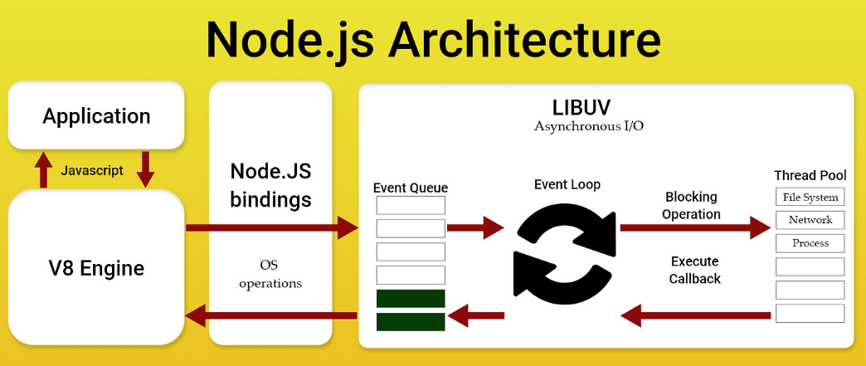

*Modules in Node.js :-
Node.js modules are an essential part of structuring and organizing code in Node.js applications. They enable code reusability and help keep your application maintainable. There are different types of modules in Node.js:
1.Core Modules:
    - These are built-in modules provided by Node.js for common functionality.
    - Core modules can be used without the need for additional installation.
    - Examples of core modules include fs (file system), http (HTTP server), url (URL parsing), path (file and directory paths), and events (event emitters).
2.Local Modules:
    - Local modules are custom modules created by the developer for specific functionality.
    - You can create your own modules to encapsulate and reuse code within your application.
    - These modules are organized in separate JavaScript files and can be loaded using the require function.
3.Third-Party Modules:
    - Third-party modules are created by the Node.js community and other developers.
    - They extend the functionality of Node.js and can be installed and managed using the Node Package Manager (NPM).
    - Examples of popular third-party modules include Express.js (web framework), Mongoose (MongoDB ODM), and Axios (HTTP client).

*Event loop :-
The event loop in Node.js is a mechanism that allows asynchronous tasks to be handled efficiently without blocking the execution of other operations. It:
- Executes JavaScript synchronously first and then processes asynchronous operations.
- Delegates heavy tasks like I/O operations, timers, and network requests to the libuv library.
- Ensures smooth execution of multiple operations by queuing and scheduling callbacks efficiently.
The Event Loop is essential in Node.js because it allows non-blocking, asynchronous operations to be handled efficiently, even though Node.js operates on a single thread.
- Enables non-blocking execution despite Node.js being single-threaded.
- Helps handle I/O-bound tasks efficiently.
- Makes Node.js suitable for scalable applications like web servers.

